User Interface & Database Schema

Document

Presented by

Peter

1.0 The Admin Navigation Area

Main Menu | Submenu

|  |  |  |
| --- | --- | --- |
|  |  |  |
|  |
|  |
|  |
|  |

2.0 The Admin Login Interface

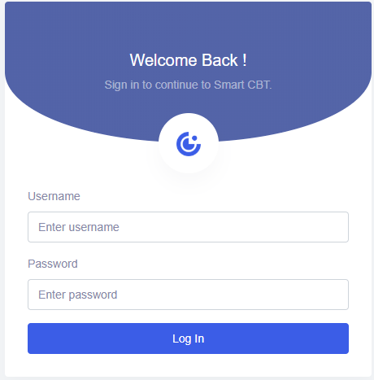

2.1 The Change Password Interface

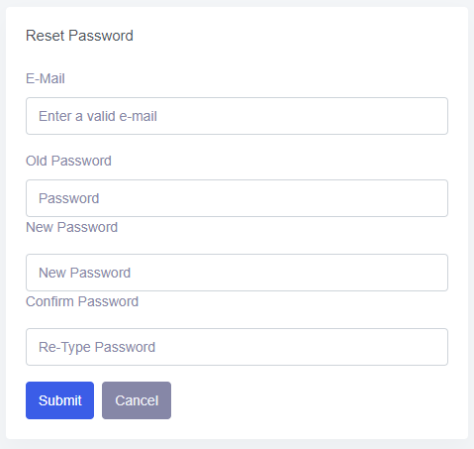

3.0 Intelligent Agent Interface

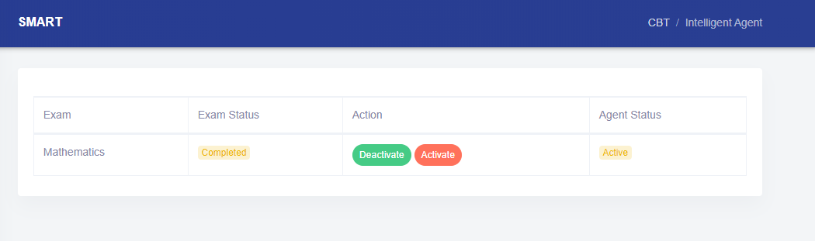

4.0 Notification Interface

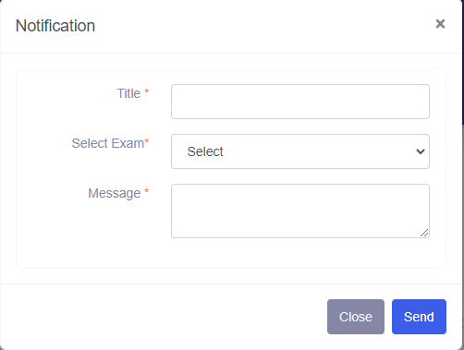

4.1 Search and View All sent Notifications

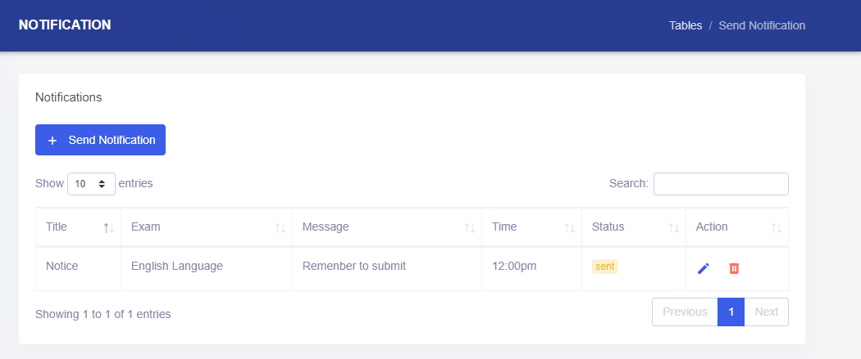

4.2 Search and View All Agent Notification

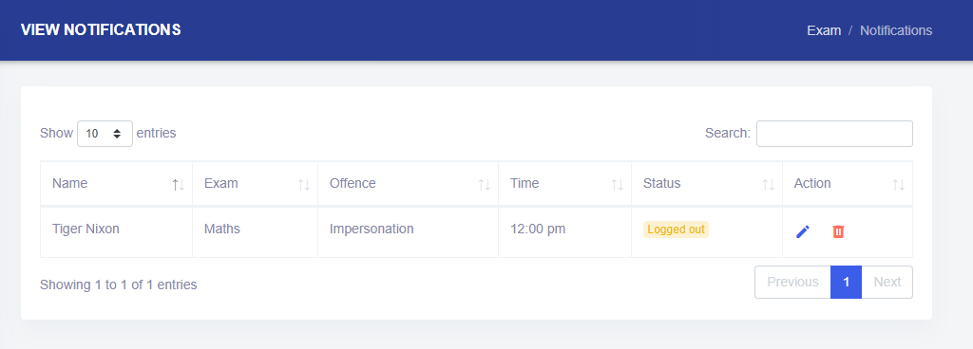

5.0 Student Registration Interface

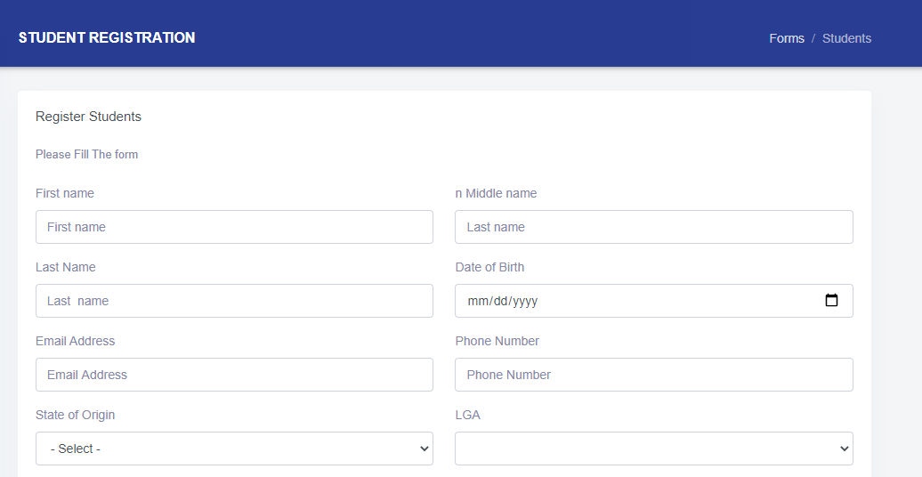

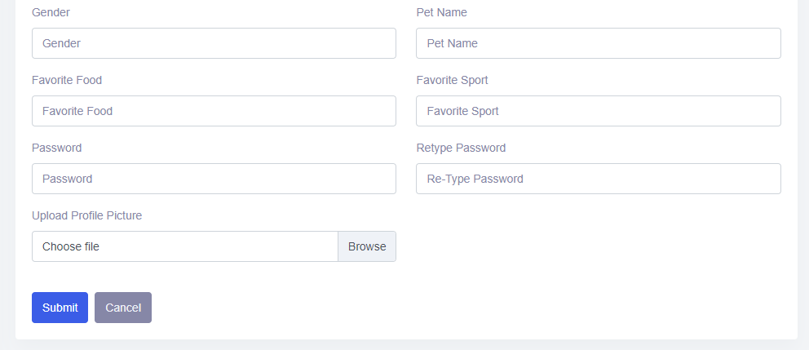

5.1 Edit and Update Student Interface

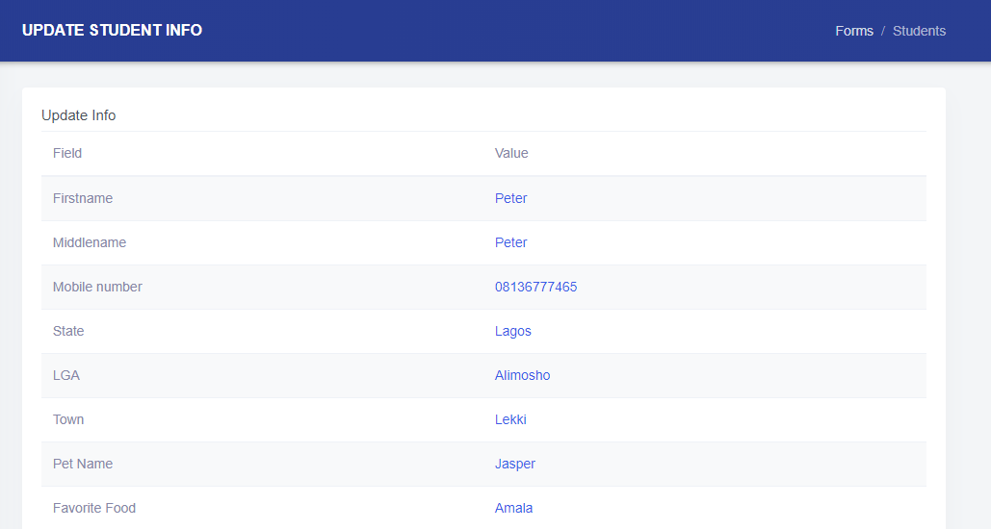

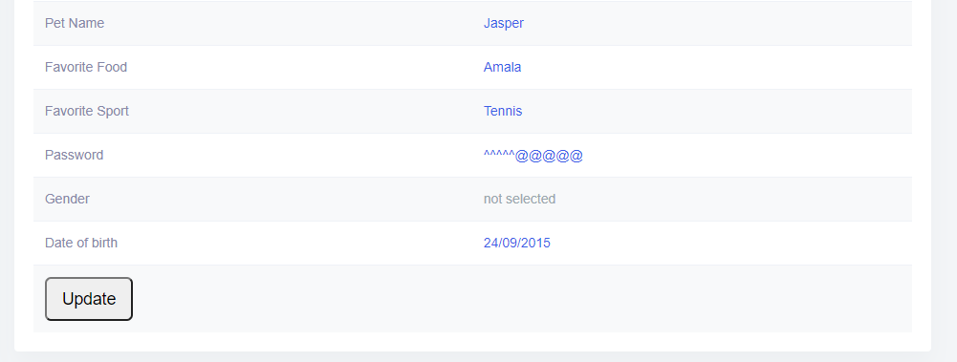

5.2 Search and View All Student Records

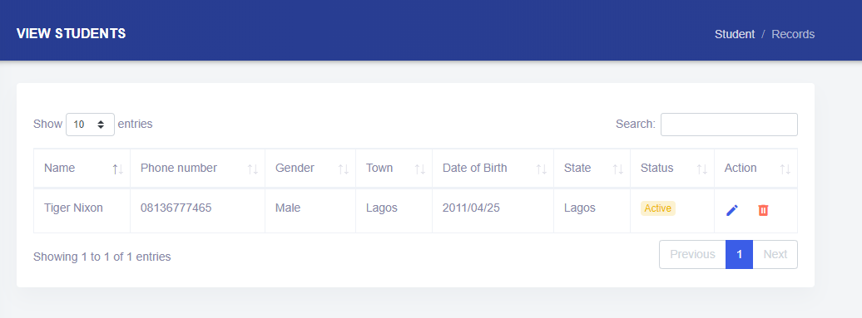

6.0 Add new Admin

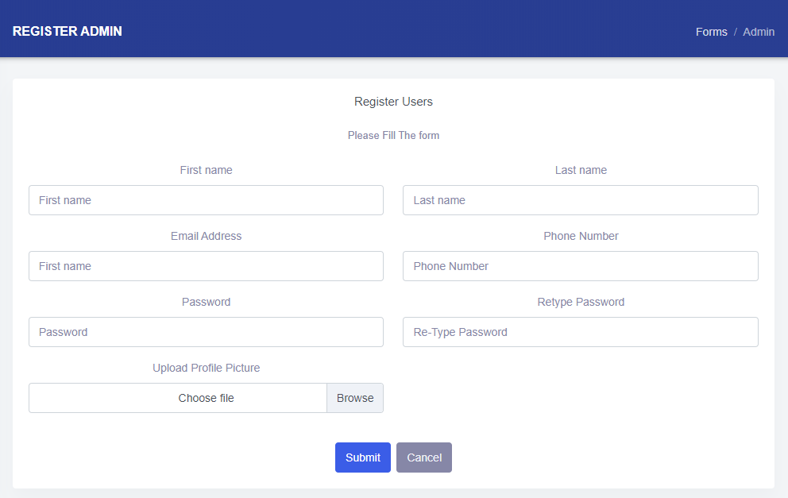

6.1 Search and View Admin Records

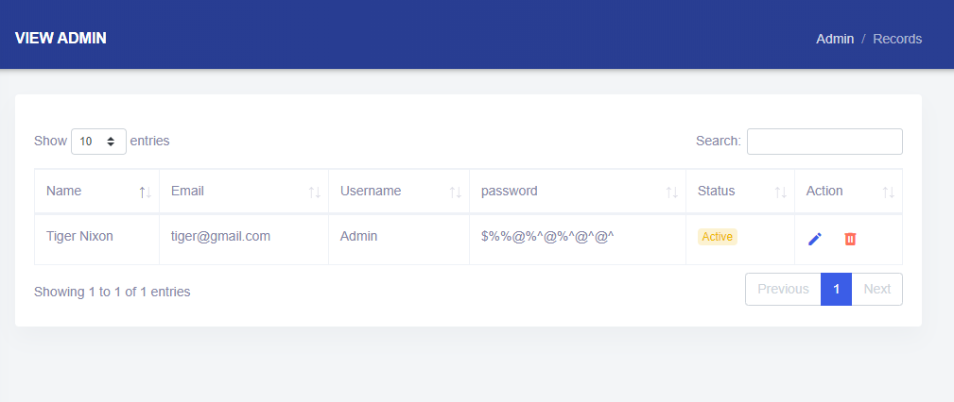

7.1 Add new Exam

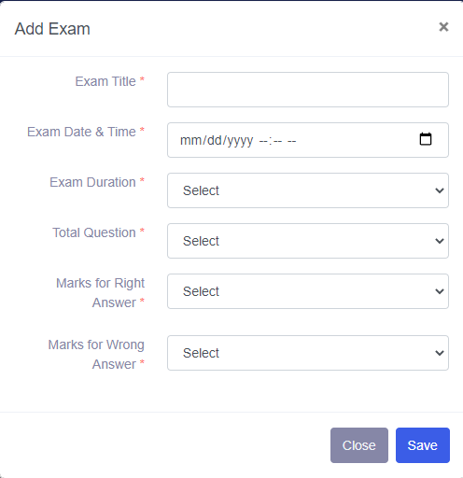

7.1 Search and View Exam Details

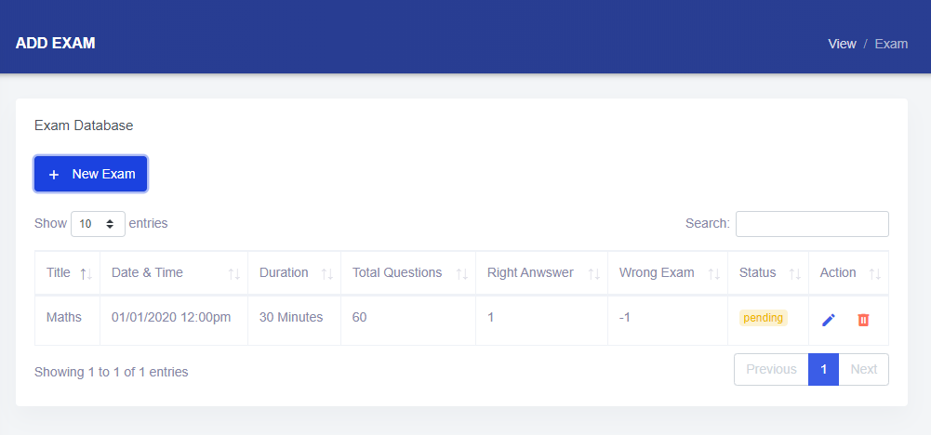

7.3 Add Exam Questions-Single

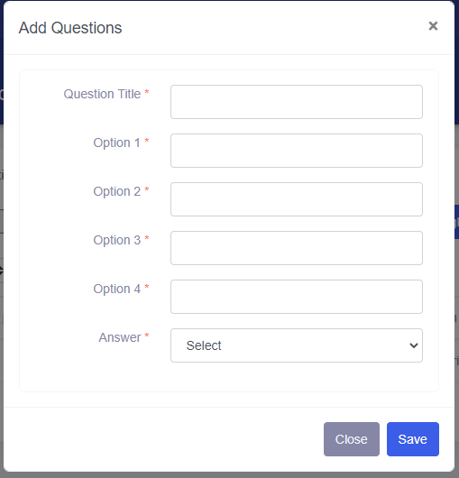

7.4 Add Exam Question-Multiple

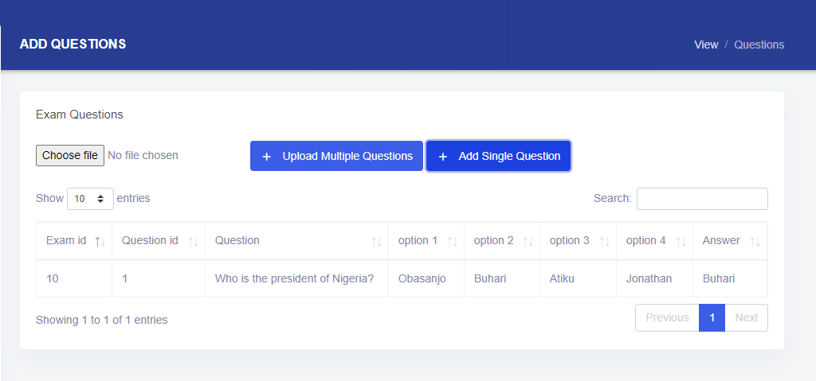

8.0 Student Report

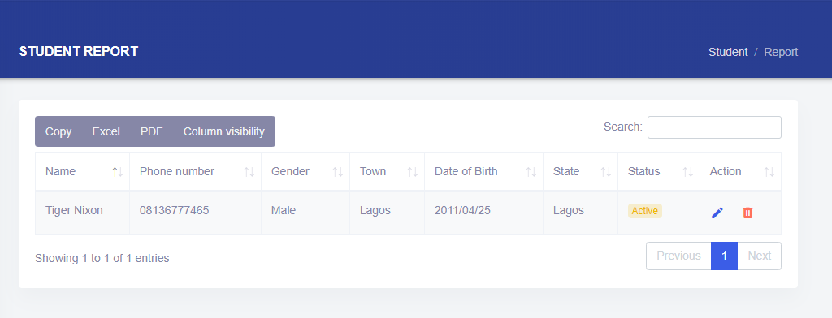

8.1 Exam Report

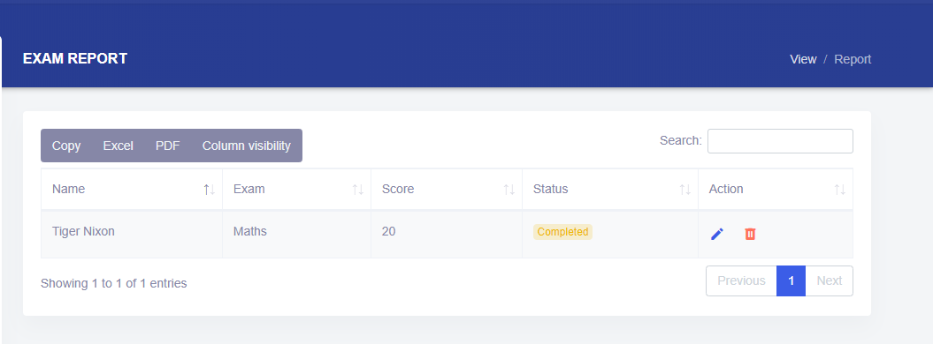

8.2 Admin Report

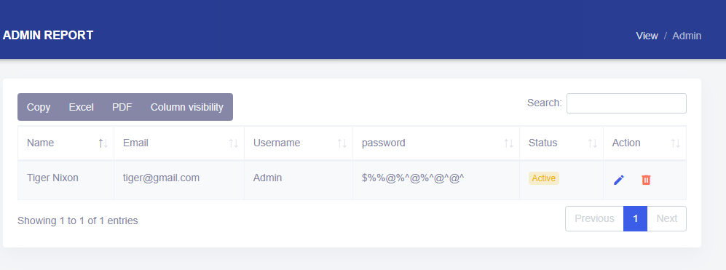

8.3 Notification Report

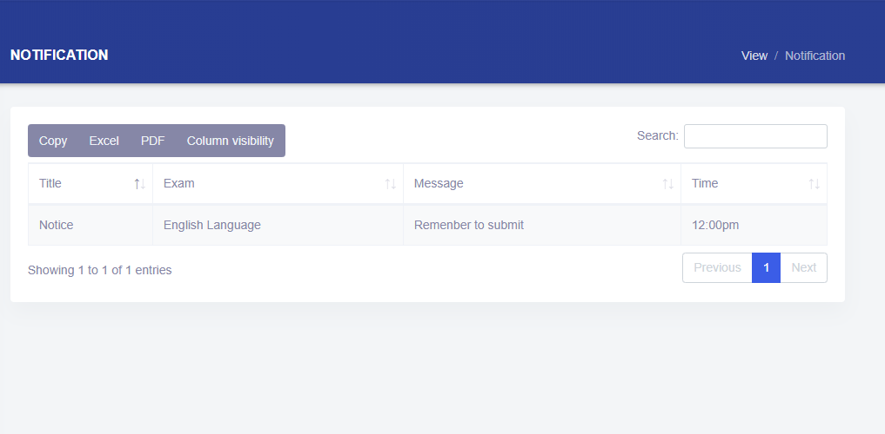

8.4 Notification Report

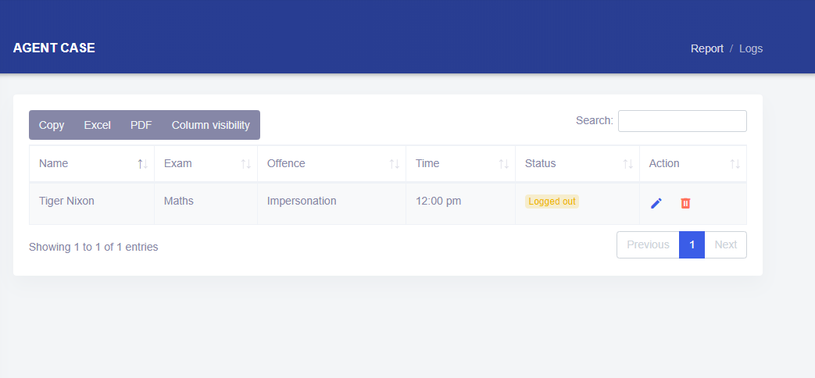

Note: The CBT System is in the next phase. The next phase deliverable in a working CBT system with a functional login mechanism and fully integrated Admin Backend. The User Interface Preview will be available at <http://beautifulcode.epizy.com/exam/>

Database Design

